BRIAN J. STIGER, Director of Consumer Affairs
Brian J. Stiger was appointed as the Director for the Los Angeles County, Department of Consumer Affairs on January 17, 2012.
Brian has a long and varied background in the consumer protection arena. Previous to his appointment with the County, Brian was appointed by former Governor Arnold Schwarzenegger on August 11, 2009, to serve as the Director of the State Department of Consumer Affairs, where he led a major effort to strengthen polices, enhance consumer protection and reform and improve the enforcement process for 37 boards, bureaus, and programs.
Previously, Brian spent two years as the Executive Officer for the Board of Chiropractic Examiners, where he successfully reformed and restructured the board's enforcement program, significantly decreasing complaint processing time and reducing the backlog of consumer complaints.
From 2004 to 2007, he served as former Governor Arnold Schwarzenegger’s Chief of the Bureau of Home Furnishings and Thermal Insulation. Brian previously served as former Governor Gray Davis’ Chief of the Bureau of Electronic and Appliance Repair from 2002 to 2004, where he helped make improvements to the operational efficiencies of the bureau and increase enforcement positions without increasing the budget.
Additionally under DCA, he held the position of Staff Services Manager I from 1996 to 2002, Associate Personnel Analyst from 1994 to 1996 and Associate Governmental Program Analyst from 1993 to 1994. In these positions, Brian worked with the various boards, bureaus and programs under DCA to resolve a variety of administrative issues and improve core functions, including enforcement activities.
Prior to that, Brian served as Associate Printing Plant Superintendent for the Department of General Services from 1990 to 1993.


EMPRESS HARBOR RESTAURANT
DINNER MENU

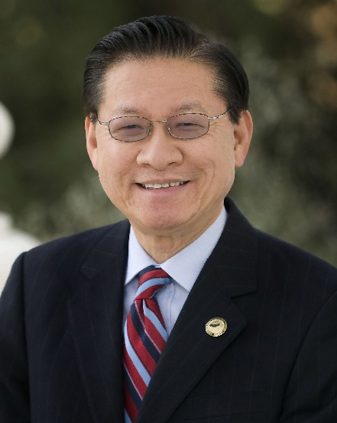
Eight Course Dinner:
Chicken Cloud Mushroom Soup
Walnut Shrimp
Filet Mignon with Broccoli
Steam White Cabbage
Crispy Chicken
Sweet and Sour Fish Filet
Garlic Pork Chop
Fried E-Fu Noodle

Dessert:
Mango Pudding

EMCEE
PHILLIP CHEN, Health Deputy, Fifth District
Phillip Chen is a school board member for the Walnut Valley Unified School District and the Health Deputy for Los Angeles County Supervisor Mike Antonovich. He is responsible for helping to formulate policy in all aspects of County health and mental health services.
Prior to joining Antonovich’s staff, he was appointed by Governor Pete Wilson to serve for the Governor’s Office of Criminal Justice Planning, where he worked on legislation involving foster care, gang prevention, drug awareness, mental health, and Planned Parenthood. Under the Office of Criminal Justice Planning, he has served on the Juvenile Justice Legislative Committee, Native American Committee, and the Mental Health Committee.
As a former member of the Physical Therapy Board for the Board of Consumer Affairs, he served on the Licensing Committee, which licenses and disciplines physical therapists and physical therapist assistants. In addition to his experiences in local and state government, Phillip is also a Reserve Deputy for the Los Angeles County Sheriff Department. He strongly believes in the concept of mentoring. Phillip continues this tradition as an Adjunct Professor of Public Administration at Cal State University Fullerton. Phillip holds a B.A. in Communications from California State University, Fullerton; a Master’s in Public Administration from the University of Southern California, and is a Doctoral candidate in Public Administration from the University of Southern California.

SPECIAL GUESTS
BRYCE YOKOMIZO, Professor and Retired Department Head
Bryce Yokomizo was a Los Angeles County employee for 33 years, and retired in 2007. He is a long-time LACAAEA member, and served as Director of the Department of Public Social Services, and County Deputy Chief Executive Officer. A graduate of UCLA and USC, Bryce is currently on faculty with the School of Public Administration at California State University, Northridge. He teaches graduate courses in Ethics, Effective Public Sector Management, Entrepreneurial Management, Organizational Leadership, and Strategic Management.

MIKE ENG, Assemblymember - 49th District
Assemblymember Mike Eng serves 7 cities in the San Gabriel Valley. His public service includes ten years as a member of his local library board leading to a brand new library addition in Monterey Park; five years on the State Acupuncture Board, service as City Councilman and Mayor in his city; and almost five years in the California State Assembly.
He serves as Chair of the Assembly Banking and Finance Committee, which has responsibility for California’s banks and credit unions, mortgages, and corporate securities laws. He also serves on Assembly Committees on Health, K12 Education, Transportation, Business and Professions. He was an at risk youth who almost dropped out of middle school; but with the help of wonderful educators and loving parents, he completed his Bachelor's, Master's, and Law Degrees. He became a lawyer and part time Community College Instructor. His leadership has brought millions of dollars and jobs to the San Gabriel Valley for clean-up of polluted drinking water; mass transit expansion, and community colleges. Assemblymember Eng is a passionate advocate for youth, immigrants, seniors, working families, and protection of the environment. He has been a legislative leader on health, mental health, environmental, and educational disparities in the Asian American and other communities.

